Olivet Presbyterian Church

159 Church Street, McConnells, South Carolina (803) 684-3719

Email: olivet_pca@bellsouth.net On the web: www.olivetpca.org
John M. “Chip” McArthur, Jr., Pastor
Austin R. Simpson, Ministerial Intern
Christopher McCartney, Choir Director/Accompanist
Robert B. Mendenhall, Sunday School Superintendent

The Session
Christopher W. Arnold Roy G. Clinton, Emeritus David R. Currence, Emeritus
Jeffery E. Fairfax, Emeritus Daniel H. Harshaw James M. Hawley, Emeritus
Robert B. Mendenhall John M. McArthur, Jr. Moderator Michael A. Nance, WIC Liaison Jason M. Petty Richard B. Summerville, Jr. William Lee Summerville, Jr., Clerk

The Diaconate
Brian J. Carlisle, Widows & Shut-ins Brent M. Christenberry, Buildings & Grounds James R. Clinton Lee K. Guempel, Safety Team Malcolm Harshaw, Treasurer John F. Hawley, Chairman Don L. Johnson David W. Kelley Michael A. Laws, Secretary Larry M. Plyler, Emeritus S. Douglas Cobb, Jr., Emeritus

The Women in the Church
Sandra Currence, President Kathy Fairfax, Nursery/Children’s Church Susan Petty, Secretary Jane Harshaw, Historian Marsha Plyler, Treasurer/Pastor's Aide Donna McArthur, Missions Frankie Guempel, Chair-Circle 2

Our Missionaries
Peter and Diane Bakelaar (MTW-Japan) Brian Howard (RUFI-Clemson Univ.)
Garry and Anita Chambers (MTW-Caribbean) Marty and Sara Driggers (Wycliffe)
Roger and Laura Dye (Family Life Global-Latin America) Michael and Tricia Lee (MTW-Panama) Debbie Richards (MTW-Japan)

Ministry Committees, 2022

Discipleship Ministries Committee
Daniel Harshaw (2022), Chairman Megan Covington (2022)
Bryce Laws (2022) Brenda Nance (2023)
Chris Arnold (2024) Jill Christenberry (2024)

Missions Committee
Rick Summerville (2022), Chairman Dennis Krueger (2022)
Donna McArthur (2022) Susan Petty (2023)
Bobby Mendenhall (2024) Brian Carlisle (2024)

Witness Committee
Jason Petty, Chairman (2022) David Currence (2022)
Brent Christenberry (2022) Laura Frame (2023)
Michael Nance (2024) Katie Summerville (2024)

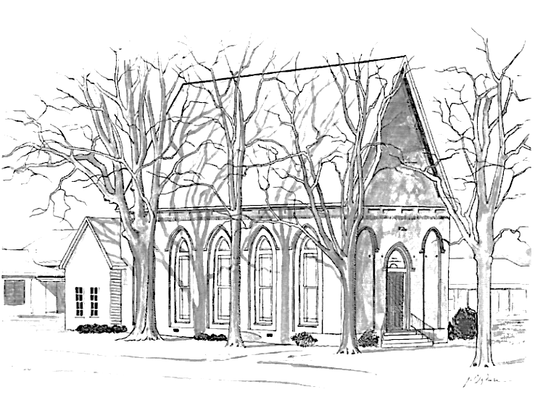

Olivet Presbyterian Church
McConnells, South Carolina

A member congregation of
The Presbyterian Church in America

Olivet Presbyterian Church
Christmas Day, December 25, 2022
Prelude Preparation for Worship
Welcome and Announcements Mr. Austin Simpson
*Call to Worship
Let us go to Bethlehem and see this thing that has happened, which the Lord has made known to us.
For to us a child is born, to us a son is given; and the government shall be upon his shoulder, and his name shall be called Wonderful Counselor, Mighty God, Everlasting Father, Prince of Peace.
Glory to God in the highest, and on earth peace among those with whom he is pleased!
(Selected verses)
*Corporate Prayer of Adoration Unison Reading
Glory be to You, O Father Almighty, who has given us Your only begotten Son, that we might live through Him.
Glory be to You, O Lord Jesus Christ, who became man that we might become the sons of God.
Glory be to You, O Holy Spirit, who rules and sanctifies our hearts.
All Glory be to You, Father, Son, and Holy Spirit, one God, world without end. Amen.

*Hymn 208 O Come, All Ye Faithful Congregation
Scripture Meditation Pastor McArthur
For God so loved the world, that he gave his only Son, that whoever believes in him should not perish but have eternal life.
…And this is the judgment: the light has come into the world, and people loved the darkness rather than the light because their works were evil.
(John 3:16, 19, ESV)
Corporate Confession of Sin
O most merciful and gracious Heavenly Father, in your great love you have given us the precious gift of your Son, yet we must acknowledge how prone we are to evil, and how slothful in doing good. You alone know how often we sin against you, how readily we wander you’re your ways, wasting your gifts, forgetting your love. Have mercy on us O Lord and forgive our sins for the sake of Your dear Son our Savior. Send your Spirit afresh. Sanctify and inflame our hearts with love for You, and for one another, and cause us to live always in Your light, and walk in humility and grateful obedience. Amen.
Pastoral Prayer
His Tithes & Our Offerings
*Doxology
*Prayer of Thanksgiving
*Hymn 211 God Rest You Merry, Gentlemen Congregation
Children’s Message Mr. Simpson
(Children aged 3 to 5 years dismissed to Children’s Church Program)
Scripture Reading Psalm 98
Sermon “Singing the New Song” Pastor McArthur
*Hymn 195 Joy to the World Congregation
*Benediction
*Offering of Praise 735 The Gloria Patri Congregation
Glory be to the Father, and to the Son and to the Holy Ghost; as it was in the beginning, is now and ever shall be, world without end. Amen, amen.

*Postlude
*Those that are able, please stand.
This Week at Olivet
Wednesday night Youth Group and Prayer Meetings
will resume next Wednesday, January 4, 2022
Looking Ahead
Next Sunday New Year’s Day – Morning Worship, 10 am
January 8 Communion Service, 10 am
Collection Duty
December John Hawley, Michael Laws, Brent Christenberry
January Brian Carlisle, John Hawley, Michael Laws
Nursery Team
Today (12/25) Gwen Carlisle, Megan Covington
Next Sunday (1/1) Sandra Currence, Addisyn Sikes
Children’s Church Team
Today (12/25) Scharlie Carlisle (T), Jill Christenberry
Next Sunday (1/1) Susan Petty (T), Richard Sikes
Church Budget Matters
Budget requirements to date (Adjusted) $ 209, 838,99
Receipts to date $ 222,725.44
Faith Promise for World Missions
2022 Faith Promise pledged, April 30, 2022: $ 21,778.00
2022 Faith Promise received to date: $ 17,166.00
Offering Envelopes
Be sure to pick up and use your 2023 Offering Envelopes which are now available in the vestibule. If you don’t find your name among the boxes, please let Malcolm know so he can get you one.
Devotional Helps
Copies of the latest editions of Tabletalk Magazine and Our Daily Bread are available for your taking in the vestibule. There you’ll also find copies of the latest edition of the PCA’s ByFaith magazine. Please help yourself to these free resources to help you grow in grace.
A Word of Thanks
The McArthurs and the Simpsons express their sincere gratitude to the WIC and the Olivet congregation for the Christmas checks and many other gifts and expressions of kindness received during the Christmas season.

